The Duke of Edinburgh
1921 – 2021
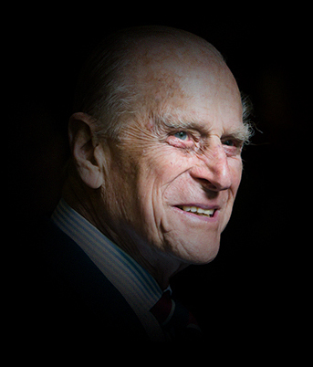
It is with deep sorrow that Her Majesty The Queen announces the death of her beloved husband, His Royal Highness The Prince Philip, Duke of Edinburgh.
- His Royal Highness passed away peacefully this morning at Windsor Castle.
- Further announcements will be made in due course.
- The Royal Family join with people around the world in mourning his loss.
- Friday, 9 April 2021

